08/01/23
THM 415: Finance
Final Exam
1. Why, under specific circumstances, corporations prefer to issue bonds with a call provision? (2 Points)
--------------------------------------------------------------------------------------------------------------------------------------------------------------------------------------------------------------------------------------------------------------------------------------------------------------------------------------------------------------------------------------------------------------------------------------------------------------------------------------------------------------------
2. The following depicts Corporate Bonds Spread Table:
Güneş Corporation is considering issuing bonds that will mature in 7 years with 9.08 % annual coupon rate. The interest will be paid quarterly. Güneş Corporation is hoping to get an A- rating on its bonds. However Güneş Corporation is not sure whether the new bonds will receive that very rating.
- What is the price of Güneş Corporation bond? (1 Point)
---------------------------------------------------------------------------------------------------------------------------------------------------------------------------------------------------------------------------------------------------------------------------------------------------------------------------------------------------------------------------------------
- What is the price of the bond if it gets a BBB rating? (1 Point)
---------------------------------------------------------------------------------------------------------------------------------------------------------------------------------------------------------------------------------------------------------------------------------------------------------------------------------------------------------------------------------------
3. Weghorst Company’s bonds mature in 28 years time and promise to pay 7.14 % coupon interest semi-annually. Suppose you purchase the bonds for $ 903.03.
a) What is Weghorst Company’s promised yield to maturity? (1 Point)
---------------------------------------------------------------------------------------------------------------------------------------------------------------------------------------------------------------------------------------------------------------------------------------------------------------------------------------------------------------------------------------
b) Assume there is a 33 % probability of default on this bond and if the bond defaults, the bondholders will receive only 70 % of the principal and interest owed. What is the expected yield to maturity on this bond? (2 Points)
-------------------------------------------------------------------------------------------------------------------------------------------------------------------------------------------------------------------------------------------------------------------------------------------------------------------------------------------------------------------------------------------------------------------------------------------------------------------------------------------------------------------------------------------------------------------------------------------------------------------------------------------------
4. Redmond Corporation is considering three mutual exclusive investments. The projects’ expected net cash flows are as follows:
a) What is the Net Present Value of Projects A, B and C at an appropriate discount rate of 3.28%? (1.50 Point)
------------------------------------------------------------------------------------------------------------------------------------------------------------------------------------------------------------------------------------------------------------------------------------------------------------------------------------------------------------------------------------------------------------------------------------------------------------------------------------------------------------------------------------------------------------------------------------------------------------------------------------------------------------------------------------------------------------------------------------------------------------------------------
- What is the Equivalent Annual Cost of Projects A, B and C? (1.50 Point)
---------------------------------------------------------------------------------------------------------------------------------------------------------------------------------------------------------------------------------------------------------------------------------------------------------------------------------------------------------------------------------------
- What are the Payback Periods for Project A, B and C? (1.50 Points)
-------------------------------------------------------------------------------------------------------------------------------------------------------------------------------------------------------------------------------------------------------------------------------------------------------------------------------------------------------------------------------------------------------------------------------------------------------------------------------------------------------------------------------------------------------------------------------------------------------------------------------------------------
- What are the MIRR’s for Project A, B and C? (3 Points)
------------------------------------------------------------------------------------------------------------------------------------------------------------------------------------------------------------------------------------------------------------------------------------------------------------------------------------------------------------------------------------------------------------------------------------------------------------------------------------------------------------------------------------------------------------------------------------------------------------------------------------------------------------------------------------------------------------------------------------------------------------------------------
- Based on MIRR, which project shall be chosen? Why? (1 Point)
---------------------------------------------------------------------------------------------------------------------------------------------------------------------------------------------------------------------------------------------------------------------------------------------------------------------------------------------------------------------------------------
5. Suarez Company is considering an independent project. The project’s expected net cash flows are as follows:
a) Calculate project’s IRR. (1 Point)
----------------------------------------------------------------------------------------------------------------------------------------------------------------------------------------------------------------------------------------------------------
b) Draw the NPV profile for the project starting with a discount rate of 2% and increments of 2 % until you reach a discount rate of 30 %. (3 Points)

- Referring to the NPV Profile prepared in part b), what is the second IRR of the project? (2 Points)
----------------------------------------------------------------------------------------------------------------------------------------------------------------------------------------------------------------------------------------------------------
- What is your decision as far as to accept the project or reject it? (2 Points)
--------------------------------------------------------------------------------------------------------------------------------------------------------------------------------------------------------------------------------------------------------------------------------------------------------------------------------------------------------------------------------------------------------------------------------------------------------------------------------------------------------------------
6. Cenk Corporation, a firm in the 22 % marginal tax bracket with a 9.03 % required rate of return or discount rate, is considering a new project. This project involves the introduction of a new product. This project is expected to last 7 years and then, because this is somewhat of a fad product, it will be terminated. Moreover, the following bits of information are pertinent to this very new project:
- Cost of new plant and equipment: $ 3,890,526
- Shipping and installation costs: $ 375,692
Year | Units Sold
1 | 100,000
2 | 120,000
3 | 150,000
4 | 180,000
5 | 140,000
6 | 92,000
7 | 54,000
- Sales price per unit: $ 75 in year 1; expected to increase by 6 % on a yearly basis.
- Variable cost per unit: $ 40 in year1; expected to increase by 3 % on a yearly basis.
- Annual fixed costs: $ 2,965,000
- Working capital requirements: There will be an initial working capital requirement of $ 1,030,000 just to get production started. For each year, the total investment in net working capital will equal 6.75 % of the dollar value of sales for that year. In the final year, all working capital is liquidated at the termination of the project.
- The depreciation method: Use the simple straight line method over 7 years. It is assumed that the plant and equipment will have no salvage value after 7 years.
a) Determine the yearly net free cash flows associated with the project? (5 Points)

- Sketch a timeline for this new project? (0.50 Points)

- Calculate the Profitability Index of the project? (1 Point)
---------------------------------------------------------------------------------------------------------------------------------------------------------------------------------------------------------------------------------------------------------------------------------------------------------------------------------------------------------------------------------------
- Shall the project be undertaken? Why? Why not? (1 Point)
--------------------------------------------------------------------------------------------------------------------------------------------------------------------------------------------------------------------------------------------------------------------------------------------------------------------------------------------------------------------------------------------------------------------------------------------------------------------------------------------------------------------
7. Muleka Company is evaluating the purchase of Jackson Company. As a first step, Muleka Company wants to determine the Weighted Average Cost of Capital (WACC) (i.e. the appropriate discount rate to discount future estimated cash flows of Jackson Company). In this regard, Muleka Company determined the following dollar values pertinent to the right hand-side of the balance sheet of Jackson Company:
- What is the weight attributed to each source of capital? (1 Point)
-------------------------------------------------------------------------------------------------------------------------------------------------------------------------------------------------------------------------------------------------------------------------------------------------------------------------------------------------------------------------------------------------------------------------------------------------------------------------------------------------------------------------------------------------------------------------------------------------------------------------------------------------
While short debt is entirely coming from a loan obtained from a private bank with a yearly interest rate of 8.14 %, long term debt is entirely coming from a 27-year issued bond (with 22 years to maturity) 7.36 % coupon rate and interest paid on a monthly basis. The bond price is currently traded at $ 914.53. Lastly suppose that marginal tax rate is 23.23 %.
- What is the cost of short-term debt? (1 Point)
---------------------------------------------------------------------------------------------------------------------------------------------------------------------------------------------------------------------------------------------------------------------------------------------------------------------------------------------------------------------------------------
- What is the cost of long-term debt? (1 Point)
--------------------------------------------------------------------------------------------------------------------------------------------------------------------------------------------------------------------------------------------------------------------------------------------------------------------------------------------------------------------------------------------------------------------------------------------------------------------------------------------------------------------
- If preferred stocks issued by Jackson Company promises to pay 9.92 % annual dividend and those very preferred stocks are traded currently at $ 1,025.90, what is the cost of preferred stock? (1 Point)
---------------------------------------------------------------------------------------------------------------------------------------------------------------------------------------------------------------------------------------------------------------------------------------------------------------------------------------------------------------------------------------
Suppose that Jackson Company’s common stockholders have received dividends (pertaining to last year) of $ 4.04 per share and that very company’s common stocks are traded currently at $ 335.85 per share. Lastly, Jackson Company has paid the following dividends during the last 9 years:
- What is the cost of common stock? (1 Point)
--------------------------------------------------------------------------------------------------------------------------------------------------------------------------------------------------------------------------------------------------------------------------------------------------------------------------------------------------------------------------------------------------------------------------------------------------------------------------------------------------------------------
- What is the Weighted Average Cost of Capital (WACC) of Jackson Company? (1 Point)
------------------------------------------------------------------------------------------------------------------------------------------------------------------------------------------------------------------------------------------------------------------------------------------------------------------------------------------------------------------------------------------------------------------------------------------------------------------------------------------------------------------------------------------------------------------------------------------------------------------------------------------------------------------------------------------------------------------------------------------------------------------------------
- Suppose Muleka Company is in need of $ 20,000,000 to finalize the acquisition of Jackson Company. Moreover, the amount needed will be financed 65 % through issuance of common stock and the remaining through issuance of bonds. Lastly, the intermediary bank responsible for the financing told that issue costs associated with bonds is 7.35 % while issue costs associated with equity is 9.96 %. What is the floatation cost associated with the acquisition of Jackson Company? (1 Point)
---------------------------------------------------------------------------------------------------------------------------------------------------------------------------------------------------------------------------------------------------------------------------------------------------------------------------------------------------------------------------------------
Muleka Company uses Discounted Payback Period as the criterion to decide whether to finalize the purchase or not. Moreover, Muleka Company values 3.00 years as the cutoff period. Finally, the estimated cash flow generated from the purchase of Jackson Company for the next 10 years is depicted as the following:
- Shall the acquisition be finalized? Why? Why not? (Show all necessary calculations) (2 Points)
-------------------------------------------------------------------------------------------------------------------------------------------------------------------------------------------------------------------------------------------------------------------------------------------------------------------------------------------------------------------------------------------------------------------------------------------------------------------------------------------------------------------------------------------------------------------------------------------------------------------------------------------------
Good Luck

THM 415 Finance
Formulae Sheet Paper
Final Exam
Chapter 9
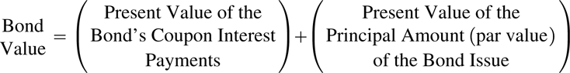
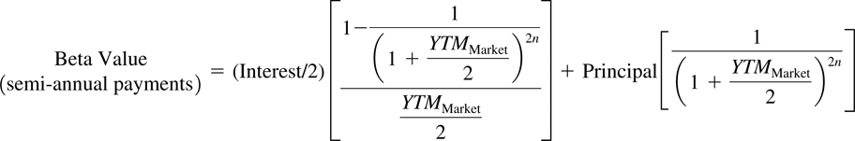
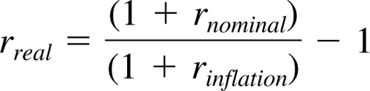
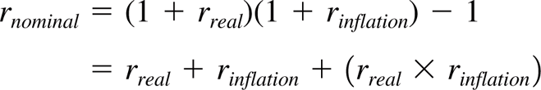
Chapter 11
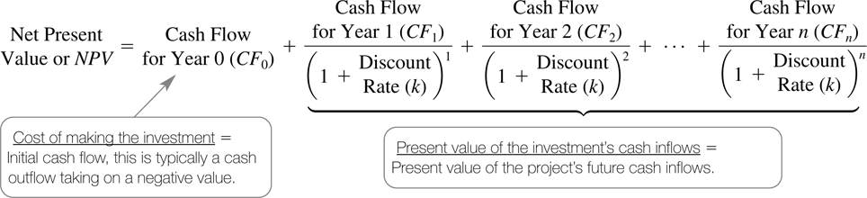
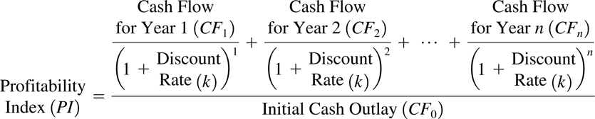
Chapter 12
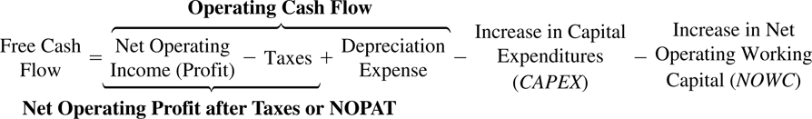
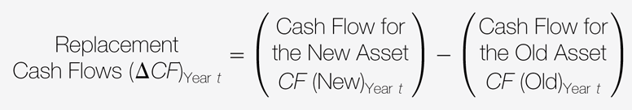
Chapter 14
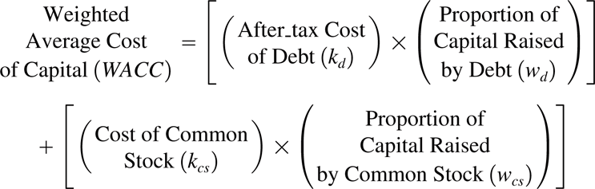
After-tax cost of debt = Yield (1 - tax rate)
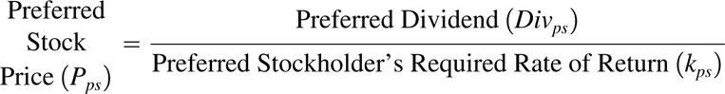
Cost of Common Equity (Dividend Growth Model):
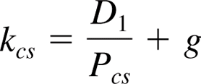
Cost of Common Equity (Capital Asset Pricing Model):
